UID LAB EXPERIMENT 9
Design input forms that validate data (e.g., email, phone number) and display error messages using HTML/CSS, JavaScript (with Validator.js)
SAILOO S
230701277
AIM
The aim of this exercise is to design input forms that validate data (e.g., email, phone number) and display error messages using HTML/CSS and JavaScript with Validator.js.

PROCEDURE
Step 1: Setting Up the HTML Form
Create an HTML form with input fields for email and phone number.
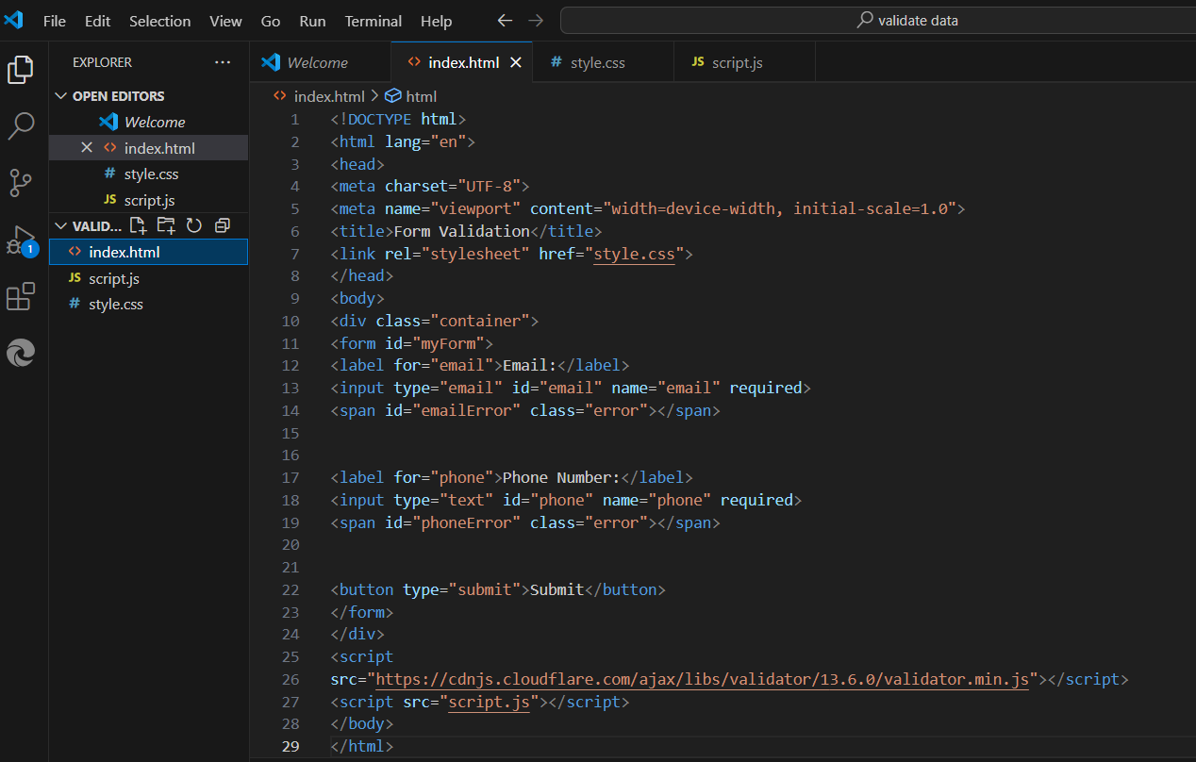
Step 2: Styling the Form with CSS
Add CSS to style the form for a better user experience.
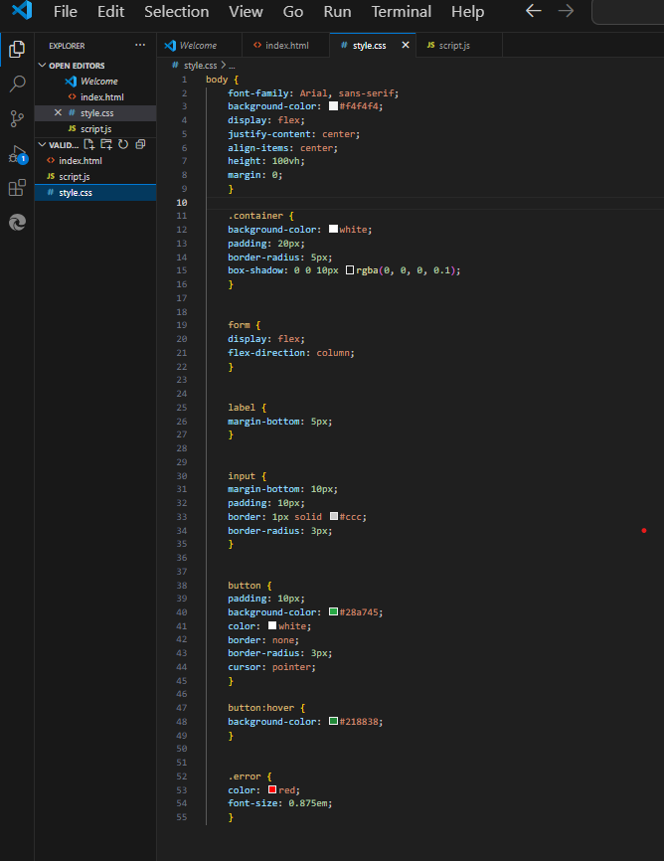

Step 3: Adding JavaScript for Validation
Use JavaScript and Validator.js to validate the form inputs and display error messages.
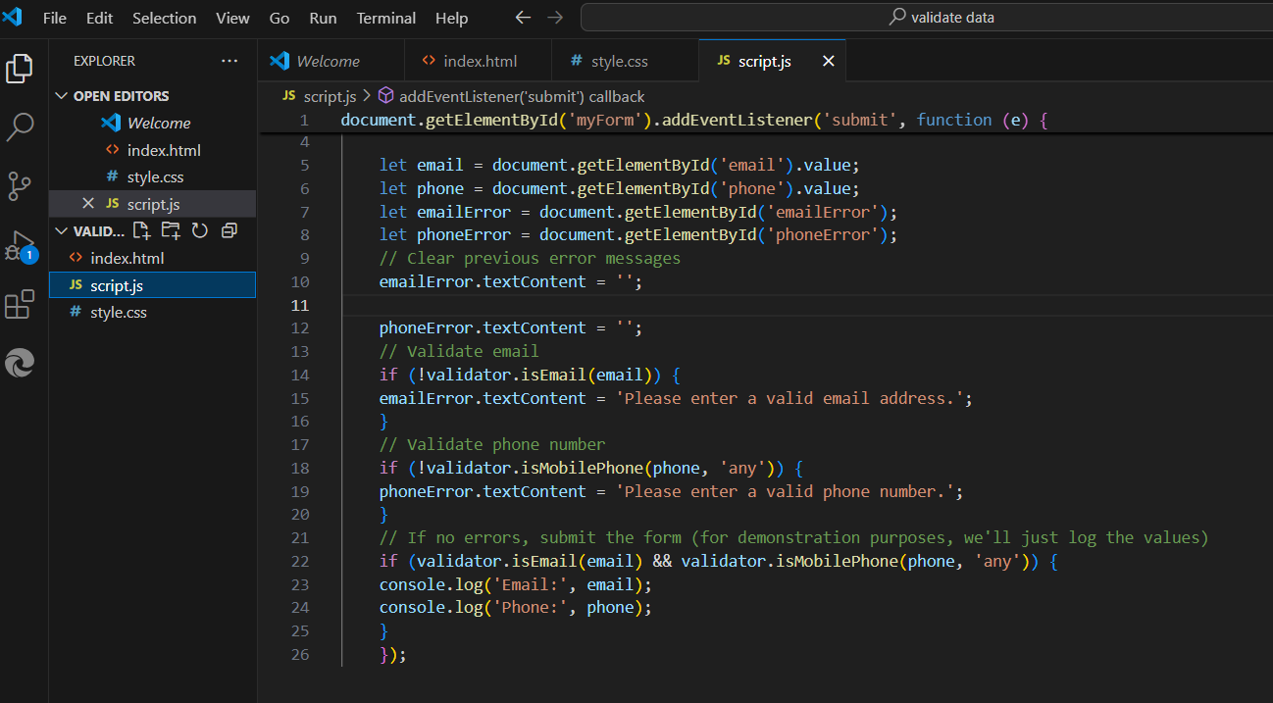

Output:
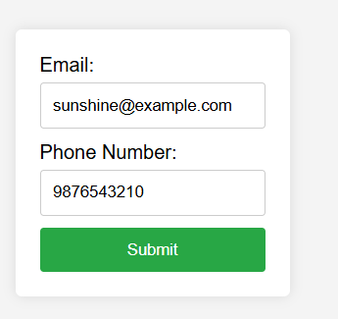
- Doesn’t show error when the email is given with @ and domain.
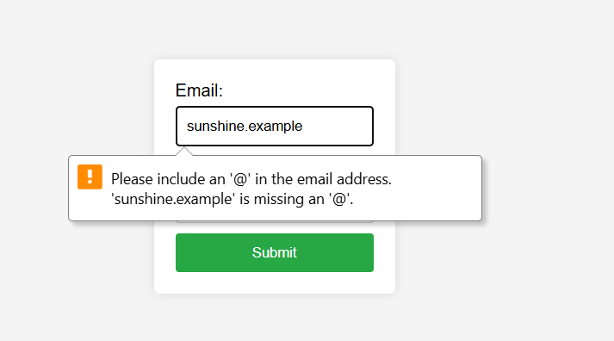
- Shows a warning message when ‘@’ symbol is missed out.
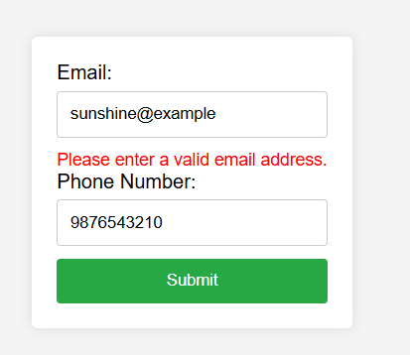
- Shows an error message whenever proper domain is missed out or not given properly.
Conclusion
This exercise demonstates how to create a form with validation for email and phone number inputs using HTML, CSS, and JavaScript with the Validator.js library. The form provides real-time error feedback to users, ensuring data is entered correctly before submission.

